Day | Date | Migraine? | Start time | End time | Total time | Severity 1-10 | Medication | Right eye | Left Eye | Right temple | Left temple | Right eyebrow | Left eyebrow | Right back of head | Left back of head
 | 1 April 2015 | Yes | 7:00 am | 9:00 am | 2 hours | 4 | Tylenol, 325 mg
1
2
3
4
5
6
7
8
9
10
11
12
13
14
15
16
17
18
19
20
21
22
23
24
25
26
27
28
29
30
31

Mark a dot on the area in which your migraine headache begins. Keep adding dots for each migraine you experience over the 4-week period.

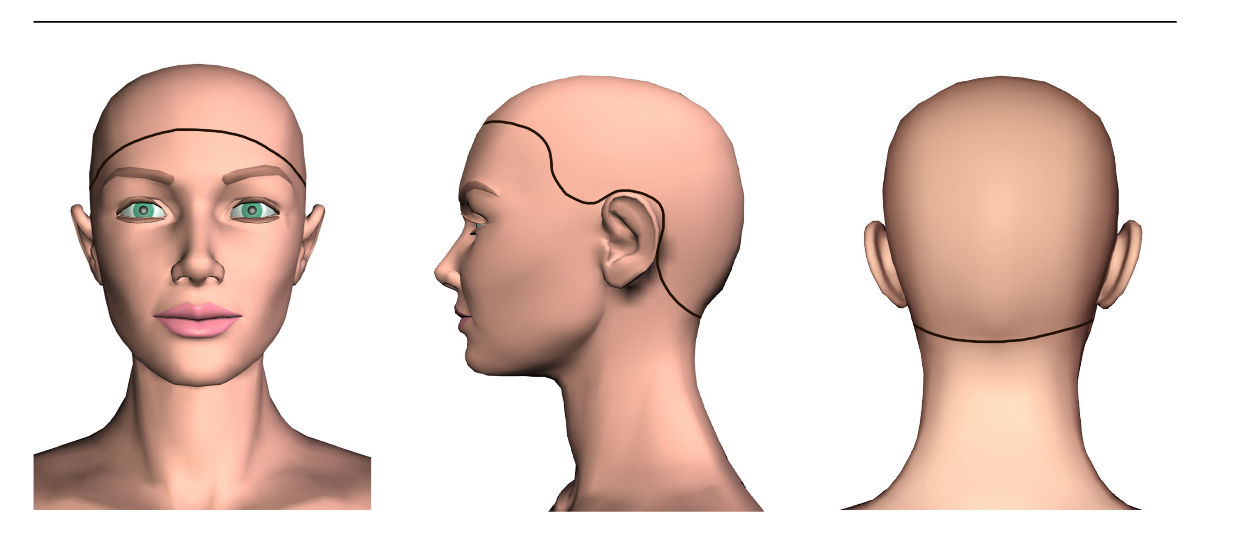

Front Side Back

